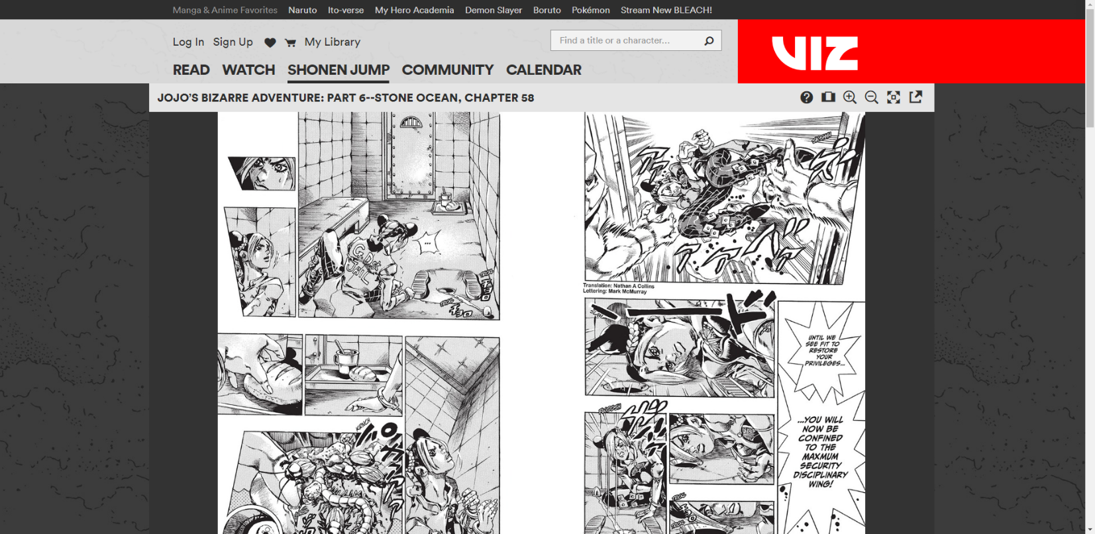

Taken from: <https://www.viz.com/shonenjump/jojos-bizarre-adventure-part-6-chapter-58/chapter/26093?action=read>

**Introduction**: Most of the sites we study and talk about in this course are sites for clients that are either trying to sell things, provide a service, tell them about their business and what nots, and thus, don’t have much content. The types of websites I’m interested in studying are those where users come to the site for the content. Things like Wikipedia, fandoms, archives of a lot of information and pages, and those that provide entertainment like stories in the above image.

Websites of the former can be artistic and eye-catching because they are trying to convince a viewer. It’s like their business card. While the latter needs a higher emphasis on Information Architecture, navigation, and the UX, so the users can comfortable consume and find the content they’re there for in an ocean of other information.

I’ve known of Viz and their service of providing manga online, but I have never been to the site. And I’m actually very disappointed with their design. So instead of talking about just the good, I’m going to point out some of the obvious flaws as well.

**Layout**: The layout is fairly simple. You have the main content take up a majority of the page and dead center. It’s very symmetrical because you have identical grey spaces on either side of the main content. But why do they have a nav bar on top of a nav bar on top of a nav bar, when they have plenty of space for a side nav while still giving the reading area the white space it deserves?

**Grid**: Viz has implemented a grid system, most likely with 12 total. The textured grey side looks to be about twice the size of the solid grey side, which would give it close to 12 total across.

**Unity:** The top nav bars and the giant red VIZ logo on the right is the only anchor for the whole website. Other pages don’t have the reader container, with some content taking up the entire width of the website with backgrounds of all colors.

**Proximity**: The nav bar items that are similar are positioned close together and on the same line.

**Repetition**: Again with the nav bar, the fonts and weight are repeated for the items on the same line.

**Contrast**: The contrast is where they fail the most. Manga is black and white (usually) so why wouldn’t they include some contrast to help show off the differences in the page?

They have a black and white-centered focal point, with a dark grey side, with another slightly less dark grey side. The series title is above with the lightest grey on the page, with a barely discernable different shade of light grey for the two-tiered nav bar. That’s a lot of grey!

The thing with websites where the user will be (hopefully) spending a lot of time reading, you want colors that are easy on the eyes. Colors that won’t over simulate and tire them out. They also don’t want colors that will be a major distraction during reading that take the reader of the immersive experience.

Those are the reasons why they choose some many shades of grey, but they could have implemented some contrast with other colors like dark greens.

And on the flip side of contrast, they seem to be breaking that own philosophy with the GIANT, BRIGHT RED logo hanging in the upper right side. It will always be a distraction in the corner of the reader’s eye, and every time the page is turned, a new webpage is loaded in, that will be the very first time the reader’s eyes goes to.

**Isolation**: They don’t use isolation all that well. The upper nav(s) need to be shorten greatly to give the main content more space and isolate it from the rest. One place they use isolation well is for the function buttons for the reading window, located right under the Viz logo. If a user would use them, they would see them. If not, they are isolated from everything else to not be a distraction while reading. (And also because the Viz logo is so overpowering it hides them well too.)

**Visual Hierarchy & Eye Movement**: Like I mentioned earlier the Viz logo has the highest visual hierarchy by a long shot. If this was CSS specificity, it would have a rank of 1,0,0,0 while the main reading content would have 0,0,1,0 and everything else 0,0,0,1.

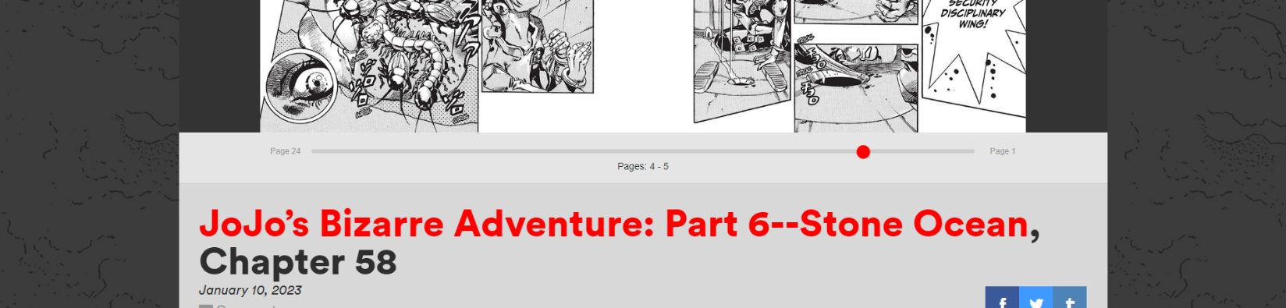

**The Fold**: This is the most infuriating part of their design; the final couple inches of the main content are “just” under the fold along with the page-turning navigation. As for UX, the user will always have to scroll down one tick to multiple times while they read across the panels. And even when you scroll down, you can’t escape from a highly distracting red theme.

**Overall**: The first thing to be done is greatly reduce the brightness and size of their logo, along with splitting up their 3-layered top nav bar into a much smaller top nav and a side nav. They should isolate the main reading area a bit from the top nav and fit the entire reading window along with the page navigation above the fold. And finally, give all the sections some contrast with different colors that are easy on the eyes and not distracting. Overall, I would say this site isn’t a good reading experience in its current state.